Evidence Output

T004:

Valid membership number.

Input number 1845.

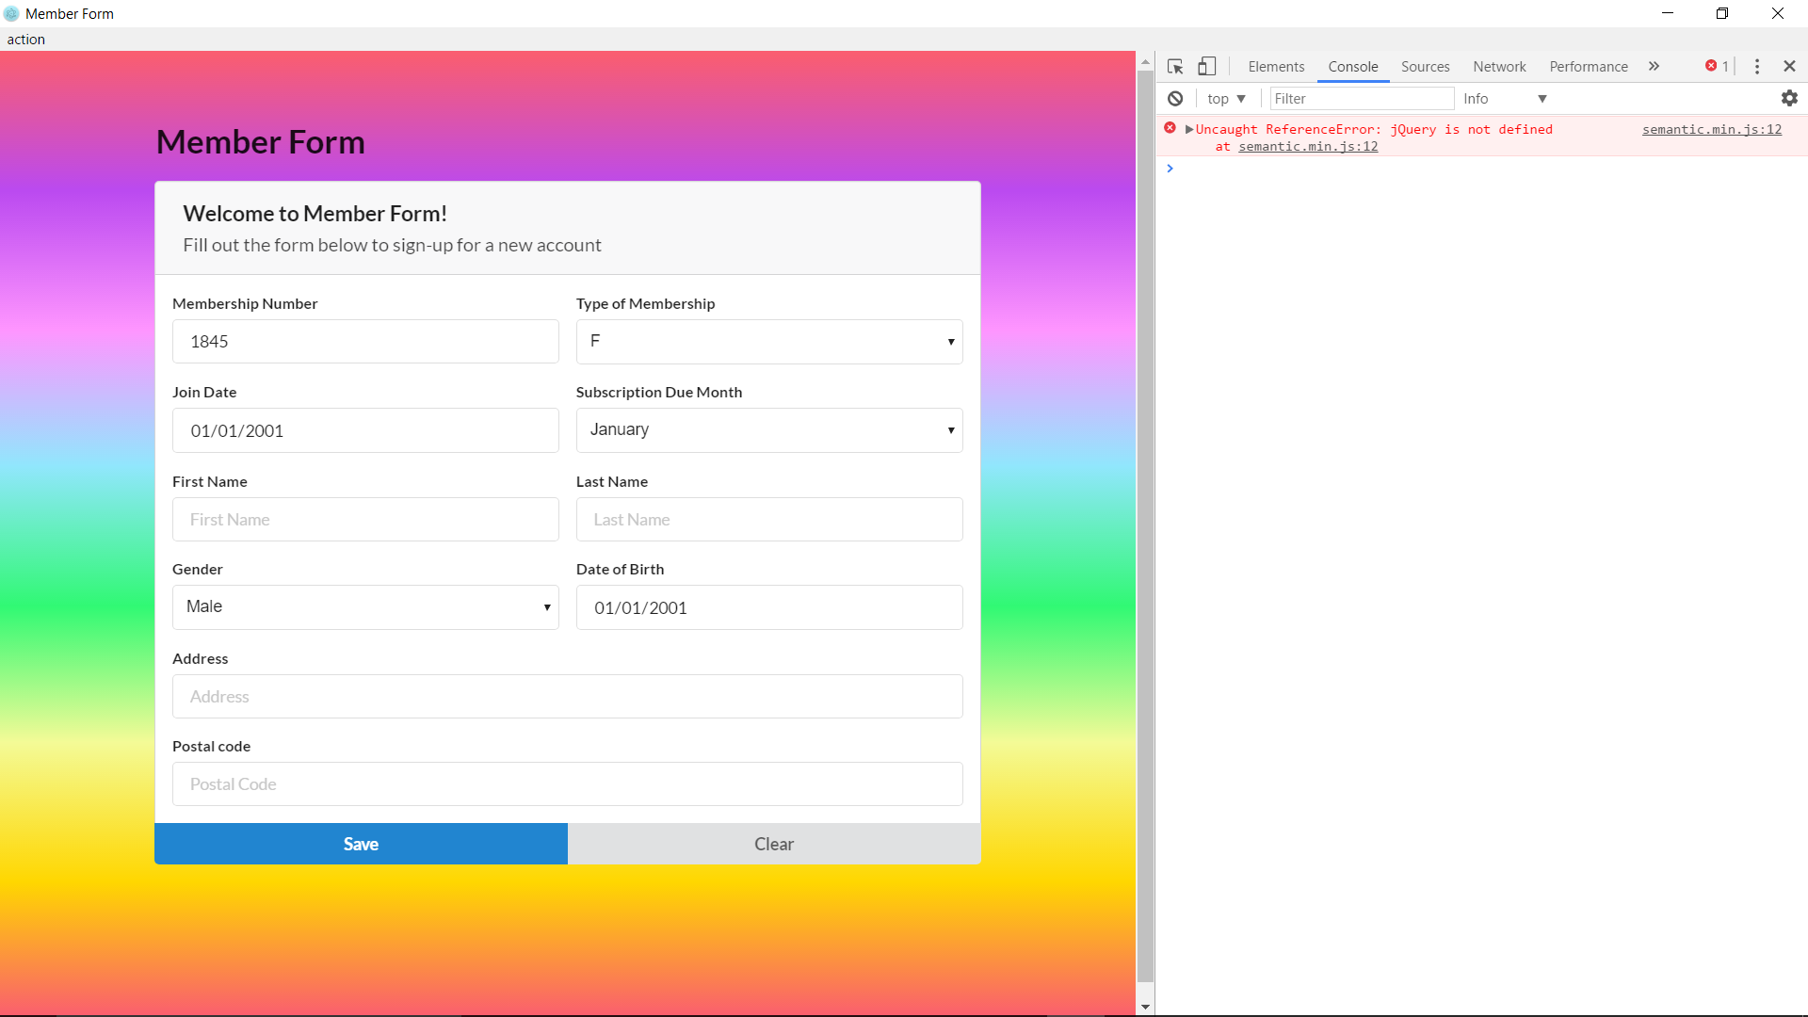

Membership number case valid fail.

